Experiment 1: Title
Student 1, Student 2, Student 3…

Department of Civil Engineering, IIT Delhi

ABSTRACT

Insert abstract text here. The abstract should concisely summarize key findings of the paper, and should consist of a single paragraph containing no more than 250 words. Please use the Times New Roman font for full paper. Abstract should provide objectives, methodology and findings/ conclusions of the experiment

OBJECTIVES
Insert introduction text here.

EXPERIMENTAL DETAILS
Insert main body text here.

RESULTS

Secondary Heading
The secondary heading use 11 pt. italic type.

Equations
Please number all equations as the sample Eq. (1).
(1)

Tables
Table captions appear above the table. See Table 1 below.
Table 1. Word font size and formatting that you can use for your manuscript
Formatting style name: | Brief description:
ABSTRACT TITLE | 11 pt. bold
Abstract body text | 11 pt.
MAIN HEADING | 11 pt. bold
Body text | 11 pt.
Figure caption | 11 pt.
Table caption | 11 pt.
Secondary Heading | 11 pt. italic bold
ACKNOWLEDGEMENTS | 11 pt. bold
REFERENCES | 11 pt. bold
Date of performing experiment: dd/mm/yyyy Date of submission: dd/mm/yyyy

Figures
Figure example is shown in Fig. 1.

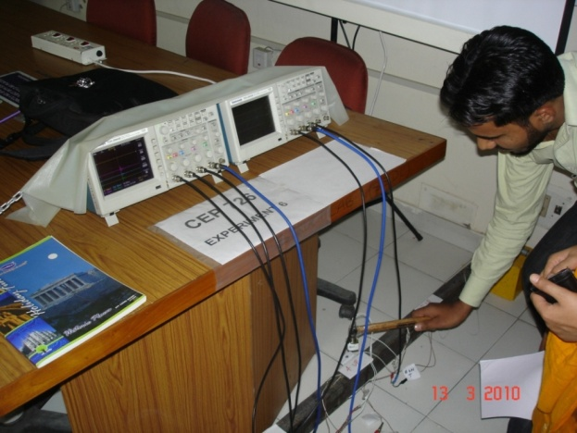
Fig. 1. Experimental set up

CONCLUSIONS
Insert main body text here.

REFERENCES
    - Brownjohn, J. M. W., Moyo, P. Omenzettor, P. and Lu, Y. (2003), “Assessment of Highway Bridge Upgrading by Dynamic Testing and Finite-Element Model Updating”, Journal of Bridge Engineering, ASCE, Vol. 8, No. 3, pp. 162-172.
    - Chopra, A. (2001), Dynamics of Structures, Prentice Hall of India limited, New Delhi.
    - PI Ceramic (2006), http://www.piceramic.de

Coordinator of the experiment

